URGENT MEDICARE NOTICE
Major care access impacts are coming!

Dear Medicare Beneficiaries, family members of Medicare Beneficiaries, future Medicare Beneficiaries, and concerned citizens,

Medicare is scheduled for a 9% reduction in payment for physical therapy services and discontinuation of Physical Therapy Telehealth services as of January 1, 2021 if congress does not act soon.

The imminent 9% reduction in payments along with the discontinuing telehealth will:
- Hurt Medicare Beneficiaries and cause harm to the integrity of the Medicare Program.
- Reduce access to Physical Therapy care through reduced offices and/or reduced staffing as well as offices being unable to continue the volume of Medicare visits they currently see.
- Eliminate access to Physical Therapy through Telehealth, a service that many patients are taking advantage of to reduce their risks during the COVID-19 pandemic.
- Jeopardize the solvency of thousands of Physical Therapy offices already struggling due to the COVID-19 pandemic. Physical Therapy Offices, including ours, may need to STOP TREATING Medicare Beneficiaries to remain solvent.

We have written letters on behalf of our company, staff, and patients, and have been working with our member organizations to try to get these devastating changes reversed.

At this point we need your help!
2 options available, PLEASE do one or both

What you can do: (Online Letter Form)
The Center for Medicare and Medicaid services is currently taking comments from the public on these impending changes. Please act quickly, the time to commend ends at 5pm on 10/5/20.
- Review the Sample Patient letter on the reverse side.
- Go to https://www.apta.org/advocacy/take-action/regulatory and click
- Scroll down to:
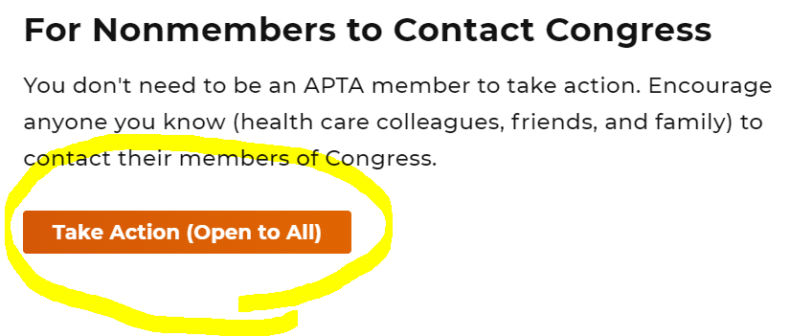
Click on the “Take Action (Open to All)
- Click on the “Congress Must Act: Stop Devastating Cuts to the Physical Therapy Profession...” 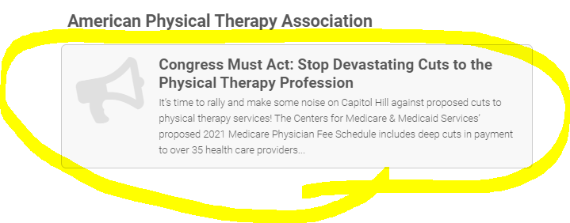
- Fill out the form, add your message and click “Send Message”.

Your participation is appreciated!

What you can do: (Call your representatives)

US Representative (CA)
Go to: https://www.house.gov/htbin/findrep
Enter your zipcode and it will show your Representative
US Senate (CA)
Senator Dianne Feinstein (CA) & Senator Kamala Harris (CA)
(202) 224-3841 (Capitol) (202) 224-3553 (Capitol)
SAMPLE CALL or EMAIL SCRIPT
My name is YOUR NAME and I'm from YOUR CITY AND STATE. Thank you for your work during these challenging times.
Physical therapy is slated for a 9% cut in the 2021 Medicare Physician Fee Schedule. This cut is unsustainable, especially given the impact of the COVID-19 pandemic. If this cut goes into effect on January 1st, many Medicare patients will find it hard to access physical therapy services.
Therapists, clinics, and rehabilitation facilities are struggling to stay open, particularly in rural and underserved areas. Now is not the time to implement payment cuts that will negatively impact patient access to care for Medicare beneficiaries. In addition, many other public and commercial insurance plans follow Medicare’s lead. So these cuts will impact Tricare and veteran’s health as well as commercial plans like Blue Cross Blue Shield, Aetna, and United Health Care.
The only way to prevent these cuts from being implemented on January 1, 2021 is for Congress to intervene. I ask that, in any upcoming and relevant legislation moving through Congress, you support inclusion of language that stop these deep Medicare cuts from being implemented. Thank you for your consideration and have a good day.

SAMPLE LETTER DIRECTLY TO CMS

Dear Administrator Verma:
I am writing in response to the request for comments on the Centers for Medicare & Medicaid Services recently proposed 2021 revisions to payment policies under the physician fee schedule and other revisions to Medicare Part B (CMS-1734-P).
I am a Medicare beneficiary and I strongly oppose CMS’ proposal to reduce payment for physical therapy providers by 9% in 2021. If this payment reduction is adopted, access to vital outpatient physical therapy services will be at grave risk. Some physical therapy providers will need to close their doors while others may choose not to continue to treat Medicare beneficiaries and/or refuse to accept new Medicare patients. This will make it more difficult for beneficiaries like me to access the services they need, leading to delays in receiving care and, as a result, a slower road to recovery. This also will lead to negative health outcomes and greater overall cost to the system. The federal government, as well as patients and taxpayers, are better served in the long run by ensuring that the Medicare program promotes efficient treatment of beneficiaries, which cannot happen unless there are enough providers to do so. As the U.S. population ages, access to these services is vital to our quality of life.
CMS has failed to consider the economic and social impacts that this significant payment reduction will have on beneficiary access to physical therapy. This massive adjustment to the fee schedule will cause disruptive reductions to revenue that, in turn, will severely jeopardize patient access to care. These concerns are magnified by the significant economic hit physical therapy providers have taken in the past few months as a result of the COVID-19 pandemic.
By hindering my ability to receive care, CMS is putting my health and the health of other Medicare beneficiaries at risk while also causing detrimental harm to the integrity of the Medicare program. I have serious concerns that my inability to receive care in a timely manner will have a compounding negative effect on my health and quality of life.
As stated above, I oppose the estimated 9% payment reduction to physical therapy providers beginning in 2021. I strongly recommend that CMS halt implementation of any cuts to physical therapy services.

Thank you for your consideration.

